**Supporting Information for**

**Metabolic traits predict the effects of warming on phytoplankton competition**

Elvire Bestion1*, Bernardo Garcia-Carreras2*, Charlotte-Elisa Schaum1, Samraat Pawar2**, Gabriel Yvon-Durocher1**

1Environment and Sustainability Institute, University of Exeter, Penryn, Cornwall TR10 9EZ, UK

2 Department of Life Sciences, Imperial College London, Silwood Park Campus, Ascot, Berkshire, SL5 7PY, UK

* Joint first authors

** Corresponding authors

**Contents**

**S1: Theory**

Figure S1A. Contour lines illustrating the competitive advantage for a range of parameter combinations, assuming nutrient saturation (R∞).

Figure S1B. Example of a reversal in the competitive advantage R across a temperature range.

**S2: Experimental design**

Figure S2A. Flow chart of the experimental design

Table S2A. Detailed information about the six species

Table S2B. Phosphate concentration levels for each solution in µmol·L-1 and µg·L-1.

**S3. Discrimination between species in the competition experiment**

Table S3A. Proportion of correct assignations for each discrimination method

Figure S3A. Example of discrimination between species among pairs of species

Figure S3B. Competition outcomes

**S4. Temperature dependence of the Monod model parameters**

Table S4A. Metabolic parameters for each alga

Table S4B. Results from the GAMs of ln( as a function of temperature

Table S4C. Results from the GAMs of ) as a function of temperature

**S5. Significance of competitive advantage predicted by the model**

Figure S5A. Histogram of proportions of competitive advantages correctly predicted for 10,000 random parameter combinations.

**S6. Robustness of the results to different statistical methods**

Table S6A. Proportion of competitive advantages correctly predicted by theory using the random forest discrimination method

Table S6B. Proportion of competitive advantages correctly predicted by theory using the rpart discrimination method

**S7. Quantitative relationship between theoretical and experimental outcomes**

Figure S7A. Correlation between the observed and predicted competitive advantages

Table S7A. Results from the linear mixed model investigating observed R as a function of predicted R

Table S7A. Results from the linear mixed model investigating observed R as a function of predicted R excluding pairs involving *Raphidocelis*.

Table S7C. Link between observed and predicted R by species

**S8. Impact of competitive interactions on polyculture yield**

Table S8A. Deviation from the expected yield per species

## S1: Theory

Our objective is to quantify how interspecific mismatches in metabolic traits affect the competitive advantage of either of a pair of competing phytoplankton species when both species are relatively rare and colonizing (co-invading) a virgin environment. For this, we start with the well-established model of two phytoplankton populations competing for a single limiting nutrient () in a chemostat-type environment (Tilman 1977, 1981):

(11a)

(11b)

(11c)

Here, *Ni* is the -th species density (cells·mL−1), *µi* is its realised growth rate (d−1), *µmax,i* is its maximum growth rate in nutrient saturated conditions (d−1), *Ks,i* is the half-saturation constant (μmol·L−1) (the nutrient concentration at which realised growth is *µmax*/2; a measure of performance at low nutrient concentrations), *S* is the nutrient concentration (μmol·L−1), *D* is dilution rate, and *S0* is the inflow concentration of nutrients. The constant *αi* converts units of nutrient to phytoplankton cell units (1000·μmol·cell−1); that is, it is the yield of species with respect to the limiting resource (inverse of the number of phytoplankton cells produced per unit of resource). The Monod equation’s parameters *µmax* and *Ks* are functional traits that depend on the species’ physiology, and play an important role in shaping competitive dynamics in phytoplankton communities (Tilman 1981; Bulgakov & Levich 1999). Because the nutrients are not replenished in our colonisation experiments, *D* = 0, leaving

(12a)

(12b)

(12c)

To calculate the competitive advantage during colonization we can assume that because the two populations are rare, cells initially grow exponentially with a constant growth rate and a negligible change in nutrient concentration over time:

(13a)

(13b)

(13c)

Then, to calculate competitive advantage when rare, we can solve eqns. 13:

(14a)

(14b)

where *t* is time (in days). Assuming (starting densities are equal; set in the experiments), we can define the competitive advantage (*R*) of species *a* relative to species *b* by taking the log of the ratio of their abundances at time *t*:

(15)

We now incorporate the effects of temperature change on the parameters *µmax* and *Ks* of eqn. 15 to predict the effects of warming on competitive advantage.

***Incorporating metabolic traits***

Maximum growth rate *µmax* is tightly coupled to the rate of net photosynthesis (Geider *et al.* 1998) and consequently, its temperature dependence is expected to be exponential up to a peak value (the optimum temperature), followed by a steeper exponential decline (Angilletta 2009; Padfield *et al.* 2016; Schaum *et al.* 2017). The temperature range of the initial exponential increase up to the optimum is the ‘operational temperature range’ (OTR) — the range most likely to be encountered by the population (Martin & Huey 2008; Pawar *et al.* 2016)

(16)

where is a mass- and temperature independent normalization constant, i.e., the value of *μ*max,*i* at a reference temperature (in K), *Eμ*,*i* is the activation energy (eV) that sets the relative rate of increase in *μ*max,*i* with temperature, *k* is the Boltzmann constant (eV·K-1), *T* is temperature (K), *m* is cell mass (size), and *β* is the exponent of the scaling of growth rate with cell size (Eppley 1972; Kagami & Urabe 2001; Brown *et al.* 2004; DeLong *et al.* 2010).We define

(17)

and therefore eqn. 16 becomes

(18)

Thus, interspecific differences in cell size *m* as well as the size scaling exponent *β* could contribute to the physiological mismatch in the species-specific normalization constants *B*0,*i*, although the species used in the experiments were specifically chosen to have approximately similar cell sizes (Table S2A).

Like *μ*max, is expected to increase with temperature (Aksnes & Egge 1991; Reuman *et al.* 2014). We therefore assume that temperature dependence within the OTR of both and follow the Boltzmann-Arrhenius equation,

(19)

where all parameters have the same meaning as in eqn. 16, and has been redefined to be a mass-scaling dependent normalization constant: . We note that compared to *μ*max, the temperature-dependence of is poorly understood, with empirical studies having documented a wide range of temperature dependence functions (Carter & Lathwell 1967; Senft *et al.* 1981; Mechling & Kilham 1982; Aksnes & Egge 1991; Sterner & Grover 1998). However, our empirical results (see Figure 1 in the main text) support the use of the Boltzmann-Arrhenius function within the OTR.

***Effects of metabolic traits on competitive advantage***

We can now substitute eqns. 18 and 19 into eqn. 15 to obtain the (relative) competitive advantage of species *a* relative to species *b* in terms of the mismatches in metabolic traits between the two species:

(20)

Thus the value of depends on the mismatches in the competing species’ metabolism, that is, on the differences in the respective parameters that define the temperature dependence of and (, , , and ). When there are no mismatches (the equivalent parameters are the same in both species), , and both species are expected to be equally abundant at any time point . When there are mismatches, , and the sign of indicates which species has a competitive advantage: for , species is expected to outnumber species at time , while the opposite is true for .

We can assess relative importance of the metabolic traits characterising nutrient limited and resource saturated growth for predicting competitive advantage by comparing the full mismatch model for *R* (eq. 20) to a simplified version that assumes nutrient saturation (as ):

In this case, species will grow faster than species *b* if , and therefore if

(22)

Here, note that because the constants *B*0*,i*include the effects of size (eqn. 17), part of the mismatch in normalization constants is expected to come from differences in cell size. The trade-off between normalisation constants and activation energies here is explicit. At , the winner is entirely determined by the ratio in the normalisation constants (the right hand side of the inequality becomes zero). However, as increases or decreases from , the relative importance of the activation energies increases, to the point that at a sufficiently large , the winner of the competition is entirely determined by whichever species has the greater activation energy (see Figure S1A below for an example). For narrower temperature ranges, such as those discussed in this study, the winner is determined by differences in both normalisation constants and activation energies.

A reversal in the competitive advantage (a change in its sign) with temperature change is also possible, and can be determined numerically. For the nutrient saturated case, the temperature at which is given by

(23)

Here, if there is a reversal, the species that wins at the higher temperature depends only on the difference in activation energies; for example, assuming a reversal takes place, if , species is expected to outcompete species for .

***Competitive advantage vs. competitive outcome***

In line with our experimental setup, the above theory investigates how the exponential growth phase during colonisation determines competitive advantage by comparing exponential growth rates of species competing for a single limiting resource. However, in the long run, and once populations reach high enough population densities, density dependence and intraspecific competition might be expected to play an increasingly important role. In the experiments, we inoculate the same (small) number of cells for both species at the start of the colonisation experiment, and then quantify the number of cells of each after 14 days. The relative abundances of each species after 14 days indicate which had a competitive advantage after colonizing an empty environment. The assumption is that the competitive advantage at 14 days carries the signature from the initial exponential growth phase as it integrates the changes in abundance over the time period, even if the species are no longer growing exponentially by the end of the experiment. For reference, the median times to carrying capacity in the growth rate experiments at 15°C were 10.5 and 14.5 days at low (1 μmol·L-1 of phosphate) and high (30 μmol·L-1 of phosphate) respectively, and 7 and 9 days respectively at 25°C.

***References***

1.  
Aksnes, D.L. & Egge, J.K. (1991). A theoretical model for nutrient uptake in phytoplankton. *Marine Ecology Progress Series*, 70, 65–72

2.  
Angilletta, M.J. (2009). *Thermal Adaptation: A Theoretical and Empirical Synthesis*. Oxford University Press

3.  
Brown, J.H., Gillooly, J.F., Allen, A.P., Savage, V.M. & West, G.B. (2004). Toward a metabolic theory of ecology. *Ecology*, 85, 1771–1789

4.  
Bulgakov, N.G. & Levich, A.P. (1999). The nitrogen : Phosphorus ratio as a factor regulating phytoplankton community structure : Nutrient ratios. *Archiv für Hydrobiologie*, 146, 3–22

5.  
Carter, O.G. & Lathwell, D.J. (1967). Effects of Temperature on Orthophosphate Absorption by Excised Corn Roots. *Plant Physiol.*, 42, 1407–1412

6.  
DeLong, J.P., Okie, J.G., Moses, M.E., Sibly, R.M. & Brown, J.H. (2010). Shifts in metabolic scaling, production, and efficiency across major evolutionary transitions of life. *PNAS*, 107, 12941–12945

7.  
Eppley, R.W. (1972). Temperature and phytoplankton growth in the sea. *Fishery Bulletin*, 70, 1063–1085

8.  
Geider, R.J., MacIntyre, H.L. & Kana, T.M. (1998). A dynamic regulatory model of phytoplanktonic acclimation to light, nutrients, and temperature. *Limnology and Oceanography*, 43, 679–694

9.  
Kagami, M. & Urabe, J. (2001). Phytoplankton growth rate as a function of cell size: an experimental test in Lake Biwa. *Limnology*, 2, 111–117

10.  
Martin, T.L. & Huey, R.B. (2008). Why “Suboptimal” Is Optimal: Jensen’s Inequality and Ectotherm Thermal Preferences. *The American Naturalist*, 171, E102–E118

11.  
Mechling, J.A. & Kilham, S.S. (1982). Temperature Effects on Silicon Limited Growth of the Lake Michigan Diatom Stephanodiscus Minutus (bacillariophyceae)1. *Journal of Phycology*, 18, 199–205

12.  
Padfield, D., Yvon-Durocher, G., Buckling, A., Jennings, S. & Yvon-Durocher, G. (2016). Rapid evolution of metabolic traits explains thermal adaptation in phytoplankton. *Ecol Lett*, 19, 133–142

13.  
Pawar, S., Dell, A.I., Savage, V.M. & Knies, J.L. (2016). Real versus Artificial Variation in the Thermal Sensitivity of Biological Traits. *The American Naturalist*, 187, E41–E52

14.  
Reuman, D.C., Holt, R.D. & Yvon-Durocher, G. (2014). A metabolic perspective on competition and body size reductions with warming. *J Anim Ecol*, 83, 59–69

15.  
Schaum, C.-E., Barton, S., Bestion, E., Buckling, A., Garcia-Carreras, B., Lopez, P., *et al.* (2017). Adaptation of phytoplankton to a decade of experimental warming linked to increased photosynthesis. *Nature Ecology & Evolution*, 1, 0094

16.  
Senft, W.H., Hunchberger, R.A. & Roberts, K.E. (1981). Temperature Dependence of Growth and Phosphorus Uptake in Two Species of Volvox (volvocales, Chlorophyta)1. *Journal of Phycology*, 17, 323–329

17.  
Sterner, R.W. & Grover, J.P. (1998). Algal growth in warm temperate reservoirs: kinetic examination of nitrogen, temperature, light, and other nutrients. *Water Research*, 32, 3539–3548

18.  
Tilman, D. (1977). Resource Competition between Plankton Algae: An Experimental and Theoretical Approach. *Ecology*, 58, 338–348

19.  
Tilman, D. (1981). Tests of Resource Competition Theory Using Four Species of Lake Michigan Algae. *Ecology*, 62, 802–815

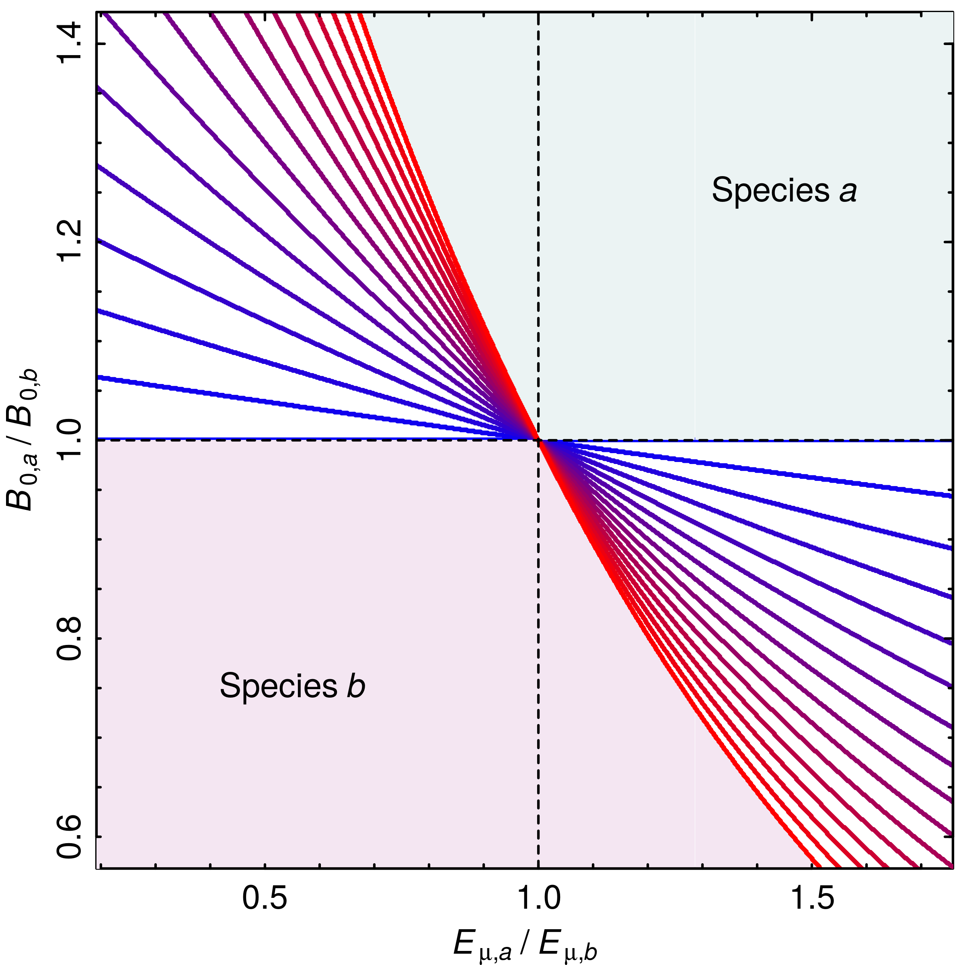

**Figure S1A. Contour lines illustrating the competitive advantage for a range of parameter combinations, assuming nutrient saturation ().** The colour of the lines correspond to different temperatures, ranging from 15°C for the blue line, to 30°C for the red line. For example, for = 1 and = 0.8, species *b* grows faster than species *a*, but for = 0.5 and = 1.2, which species grows faster depends on the temperature. Here, , , and °C. Therefore, at °C, which species wins is determined by (the blue line is horizontal and insensitive to the ratio in activation energies), while as temperatures move further away from , the ratio of activation energies becomes increasingly important in determining the competitive advantage. As temperature increases beyond the range shown here, the lines become increasingly vertical, and as a result, insensitive to the ratio of normalization constants.

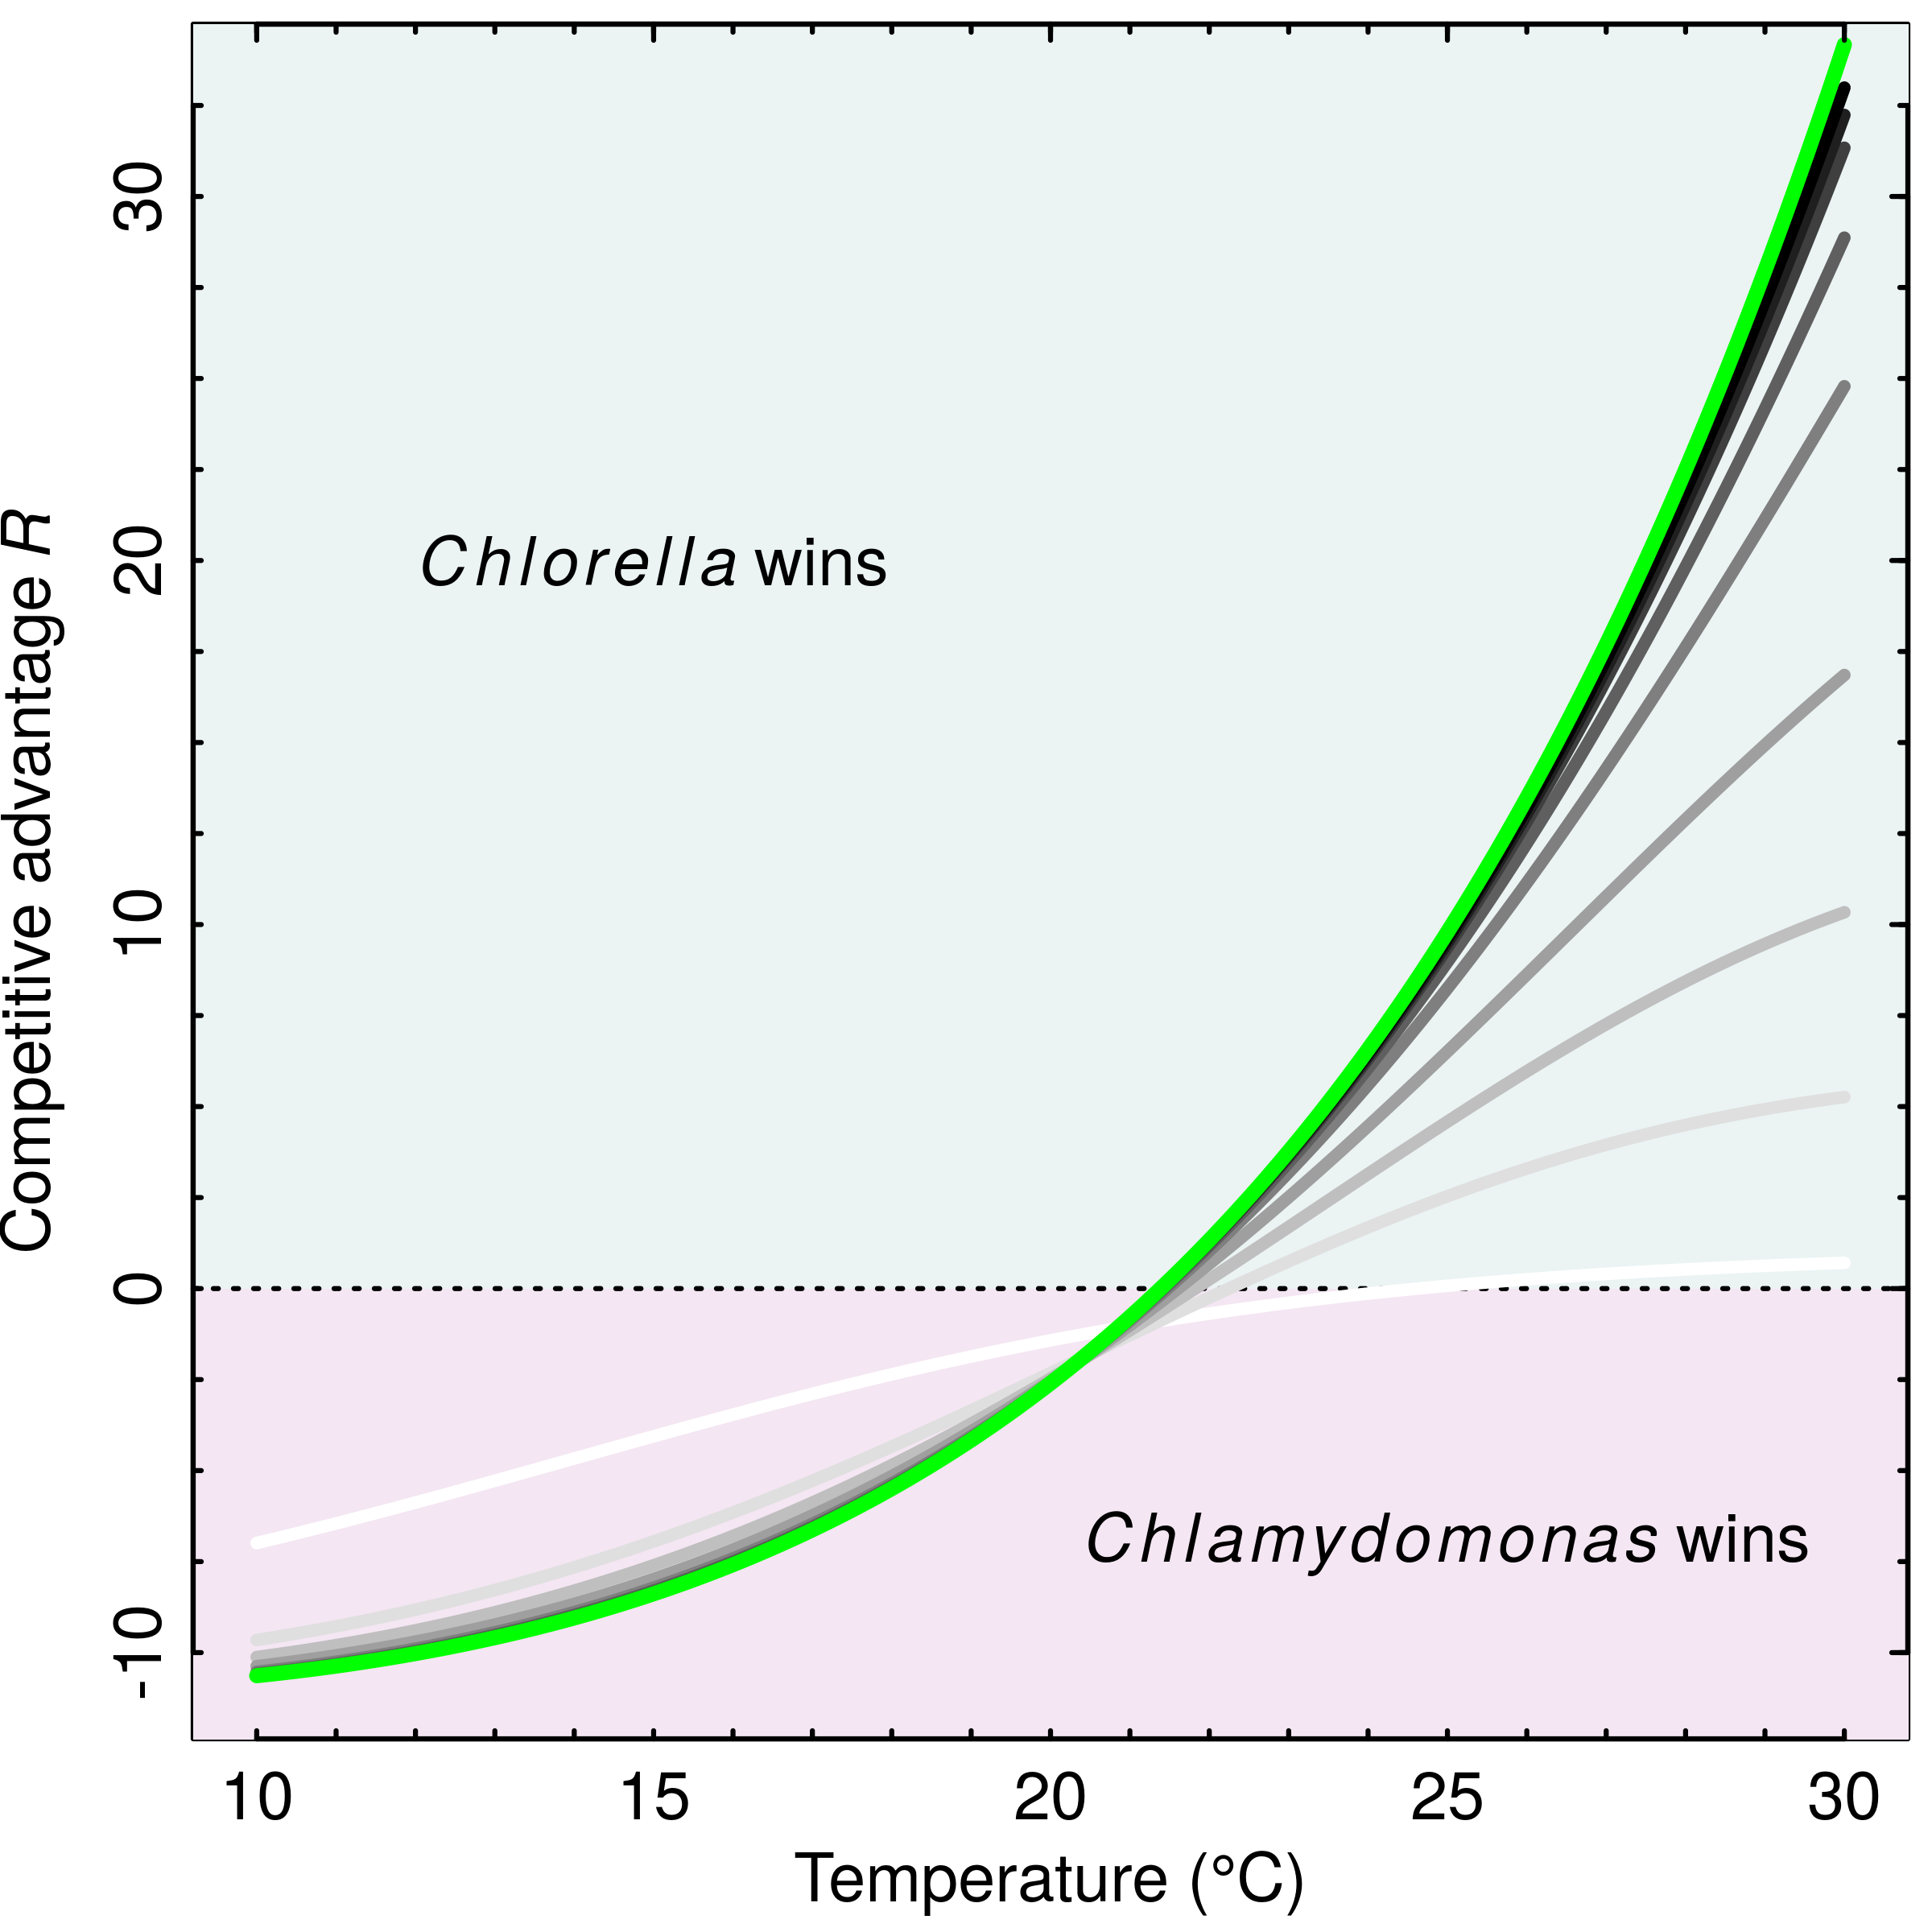

**Figure S1B.** **Example of a reversal in the competitive advantage across a temperature range.** The green line is for nutrient saturated conditions (), and the grayscale lines are for different nutrient concentrations, ranging from µmol·L-1 for the light gray line, to 50 µmol·L-1 for the black line. The example uses parameters for *Chlorella* and *Chlamydomonas*, where means *Chlorella* has a competitive advantage over *Chlamydomonas*.

## S2: Experimental design

### Figure S2A. Flow chart of the experimental design

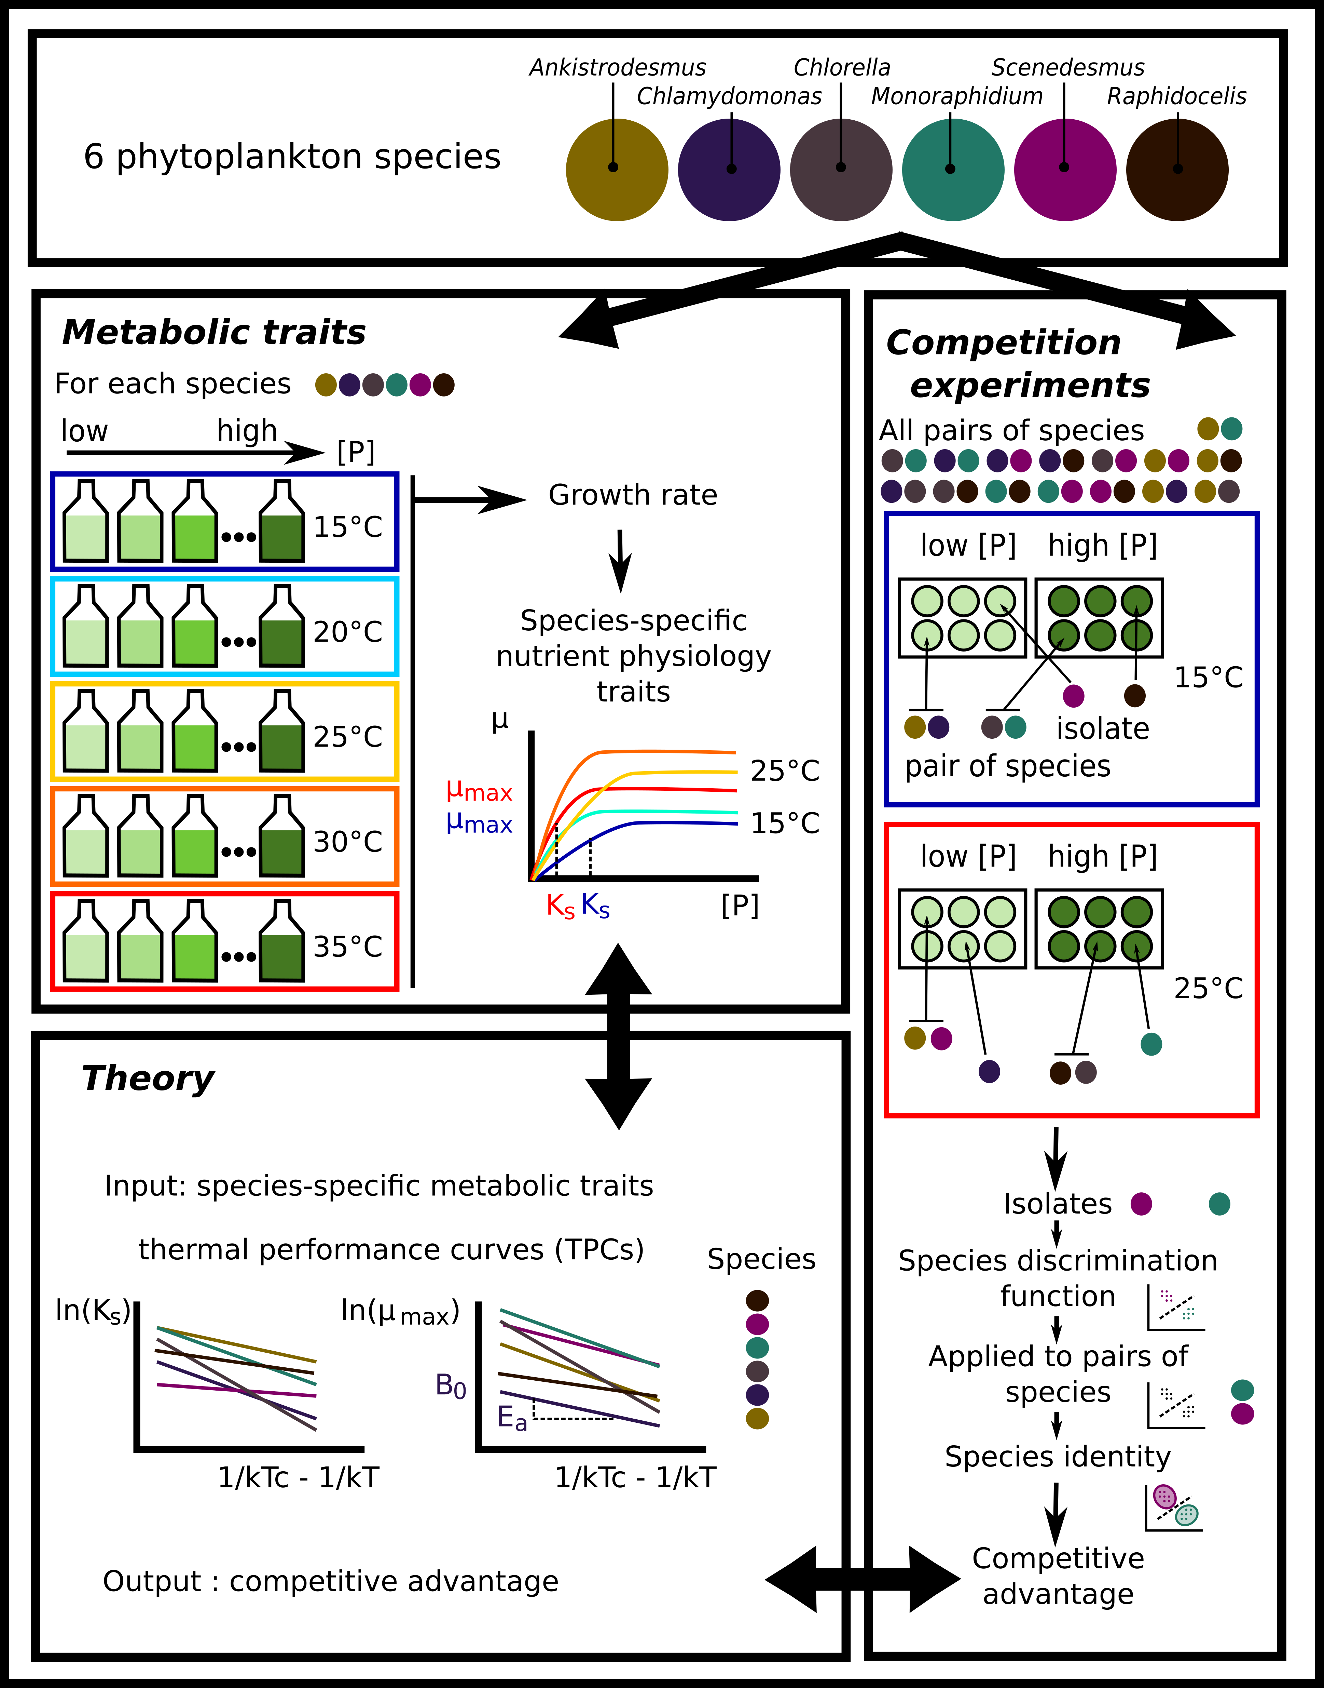

### Table S2A. Detailed information about the six species. The species were ordered from the Culture Collection of Algae and Protozoa ([www.ccap.ac.uk](http://www.ccap.ac.uk)). Cell diameters are calculated from microscopy pictures as the average of the longest and shortest diameter of the cell over 30 cells.

|  |  |  |  |  |  |
| --- | --- | --- | --- | --- | --- |
| **Species name** | **Class** | **Order** | **Strain** | **Origin** | **Mean cell diameter (µm)** |
| *Ankistrodesmus nannoselene*  Skuja (1948) | Chlorophyceae | Sphaeropleales | CCAP 202/6A | Siggeforsajon, Sweden (1948) | 2.8 |
| *Chlamydomonas moewusii*  Gerlof (1940) | Chlorophyceae | Chlamydomonadales | CCAP 11/5A | Freshwater | 8.1 |
| *Chlorella sorokiniana*  Shihira & Krauss (1965) | Trebouxiophyceae | Chlorellales | CCAP 211/8K | Austin, Texas, USA (1953) | 4.2 |
| *Monoraphidium minutum* (Nägeli)  Komarkova-Legnerova (1969) | Chlorophyceae | Sphaeropleales | CCAP 278/3 | Texas, USA | 4.7 |
| *Scenedesmus obliquus* (Turpin) Kützing (1833) | Chlorophyceae | Sphaeropleales | CCAP 276/3B | Lund, Sweden (1939) | 7.1 |
| *Raphidocelis subcapitata* (formerly  *Selenastrum capricornutum)*  Printz (1913) | Chlorophyceae | Sphaeropleales | CCAP 278/4 | Akershus, Norway (1959) | 5.8 |

### Table S2B. Phosphate concentration levels for each solution in µmol·L-1 and µg·L-1. We created 13 solutions of different phosphate concentrations ranging from 0.01 µmol·L-1 of phosphate to 50 µmol·L-1 of phosphate by mixing different amounts of COMBO medium without potassium phosphate dibasic (P- COMBO) and normal COMBO medium (P+ COMBO) in 40 mL tissue culture flasks. We used a modified version of the standard COMBO medium without animal trace solution in which we increased the fraction of carbonate by adding 10 mL of a stock solution of 55.8 g·L-1 of sodium bicarbonate to maintain a DIC of more than 6.6 mmol·L-1 in order to prevent carbon limitation, which maintained a C:N:P ratio of 132:20:1 in the P+ COMBO solution, above the Redfield ratio of 106:16:1.

|  |  |  |  |  |  |  |  |  |  |  |  |  |  |
| --- | --- | --- | --- | --- | --- | --- | --- | --- | --- | --- | --- | --- | --- |
| Phosphate concentration (µmol·L-1 ) | 50 | 40 | 30 | 20 | 10 | 8 | 6 | 4 | 2 | 1 | 0.5 | 0.1 | 0.01 |
| Phosphate concentration (µg·L-1 ) | 4750 | 3800 | 2850 | 1900 | 950 | 760 | 570 | 380 | 190 | 95 | 47.5 | 9.5 | 0.95 |
| Amount of P+ COMBO (mL) | 40 | 32 | 24 | 16 | 8 | 6.4 | 4.8 | 3.2 | 1.6 | 0.8 | 0.4 | 0.08 | 0.008 |
| Amount of P- COMBO (mL) | 0 | 8 | 16 | 24 | 32 | 33.6 | 35.2 | 36.8 | 38.4 | 39.2 | 39.6 | 40 | 40 |

## S3. Discrimination between species in the competition experiment

To investigate the joint effects of temperature and phosphate availability on competition, we competed all species in all pairwise combinations (15 pairs) at two temperatures (15 and 25°C; low temperature and a temperature close to the optimum for most species, Fig. 1) and two phosphate concentrations (saturating [30 µmol·L-1] and limiting [1 µmol·L-1] concentrations, chosen from the Monod curves, Fig. 1), with each replicated 6 times (Fig. S2A). Along with the pairwise competition trials, we grew all 6 species in monoculture at the two temperatures and two nutrient levels. This was to train the discrimination algorithm used to separate cells from different species in the competition trial. The monoculture trials were divided into two subsets, one to train the cell discrimination algorithm, which was replicated 3 times per temperature and nutrient levels, and a testing subset used to test the accuracy of the cell discrimination algorithm, which was replicated 6 times. This testing subset was also used to calculate total yield in monoculture to compare it to yield in biculture (see Section S8). The competition experiments were carried out in 24 well plates filled with 2 mL of media, and inoculated with 100 cells·mL-1 of each species. Plates were covered with AeraSealTM breathable membrane, minimising evaporation and contamination but allowing gas exchange. The competition plates were incubated in the same way as described above for the monoculture growth curves. After 14 days, a 200 µL sample was taken and preserved as described above. Cell density was determined by flow cytometry on the slow flux setting (14 µL·min), counting 20 µL per sample.

FSC files returned by the flow cytometer were read with the Bioconductor ‘FlowCore’ package in R, returning side scatter (SSC), forward scatter (FSC), green fluorescence (FL1), orange fluorescence (FL2), red fluorescence (FL3), and blue fluorescence (FL4) values that could be used to define species morphology and pigment composition and thus discriminate between species in the pairwise competition assays. We first filtered the data to remove noise by removing every data point where either ln(FSC.H)<10.3, ln(SSC.H)<3 or ln(FL3.H)<1.5, which are below minimum values observed for life cells of all 6 species. The training dataset was used to determine discrimination functions between pairs of species. We first removed outliers from this dataset by manually inspecting FSC.H by FL3.H clustering plots and choosing visual thresholds for these two values for each species. We then applied 3 different procedures to discriminate between pairs of species for each temperature and phosphate level: a linear discriminant analysis with the ‘lda’ function from the ‘MASS’ package, a random forest analysis with the ‘randomForest’ function from the ‘randomForest’ package and a recursive partitioning and regression tree analysis with the ‘rpart’ function from the ‘rpart’ package. These analyses were performed using the natural logarithm of the 10 variables returned by the flow cytometer (that is FSC.H, FSC.A, SSC.H, SSC.A, FL1.H, FL1.A, FL2.H, FL2.A, FL3.H, FL3.A, FL4.H and FL4.A, .H standing for height and .A for area), on each of the 15 pairs of species for each combination of temperature and phosphate level. These different discriminant functions were then applied to the testing dataset to test the accuracy of the predictions for the different discriminant methods. For each pair of species, we used the training set to create *in silico* competition experiments where 100% of the cells would pertain to one of the species. We applied the discrimination algorithm and calculated the percentage of times where a cell was wrongly attributed to the other species. We then chose the method that gave the maximum level of accuracy to apply to the competition dataset (Fig. S3A). The best method was the linear discriminant analysis, which gave 84% accuracy (Table S3A).

After determining species identity for each sample, we computed cell density and calculated the competitive advantage of species *a* relative to species *b* by taking the ln ratio of their densities (cells·mL-1) at time *t*, adding 1 to each species density to for instances when one species became locally extinct (e.g. density = 0). We also computed a binary competitive advantage where species *a* was competitively dominant when and vice versa. In comparisons with the model, we removed 14 replicates for which the observed *R* = 0, because the model necessarily predicts a non-zero *R* (traits characterising the TPCs for *µ*max and *KS* were never identical for any species pair).

### Table S3A. Proportion of correct assignations for each discrimination method. LDA: linear discriminant analysis, Random Forest analysis, RPART: recursive partitioning and regression tree. Summarised by (a) species for all nutrient and thermal conditions, (b) pair of species for all nutrient and thermal conditions, (c) phosphate and nutrient conditions for all pair of species.

a

|  |  |  |  |
| --- | --- | --- | --- |
| **Species** | **LDA** | **Random forest** | **RPART** |
| *Ankistrodesmus* | 0.91 | 0.86 | 0.72 |
| *Chlamydomonas* | 0.93 | 0.93 | 0.81 |
| *Chlorella* | 0.85 | 0.86 | 0.67 |
| *Monoraphidium* | 0.84 | 0.78 | 0.65 |
| *Scenedesmus* | 0.83 | 0.77 | 0.61 |
| *Raphidocelis* | 0.70 | 0.68 | 0.48 |
| **Mean** | **0.84** | **0.81** | **0.66** |

b

|  |  |  |  |
| --- | --- | --- | --- |
| **Pair of species** | **LDA** | **Random forest** | **RPART** |
| *Ankistrodesmus-Chlamydomonas* | 1 | 1 | 0.94 |
| *Ankistrodesmus-Chlorella* | 0.91 | 0.88 | 0.73 |
| *Ankistrodesmus-Monoraphidium* | 0.87 | 0.74 | 0.71 |
| *Ankistrodesmus-Scenedesmus* | 0.95 | 0.93 | 0.71 |
| *Ankistrodesmus-Raphidocelis* | 0.82 | 0.73 | 0.52 |
| *Chlamydomonas-Chlorella* | 0.96 | 0.96 | 0.79 |
| *Chlamydomonas-Monoraphidium* | 0.96 | 0.97 | 0.86 |
| *Chlamydomonas-Scenedesmus* | 0.94 | 0.92 | 0.74 |
| *Chlamydomonas-Raphidocelis* | 0.78 | 0.8 | 0.74 |
| *Chlorella-Monoraphidium* | 0.83 | 0.85 | 0.7 |
| *Chlorella-Scenedesmus* | 0.86 | 0.84 | 0.65 |
| *Chlorella-Raphidocelis* | 0.67 | 0.76 | 0.48 |
| *Monoraphidium-Scenedesmus* | 0.88 | 0.69 | 0.63 |
| *Monoraphidium-Raphidocelis* | 0.68 | 0.67 | 0.33 |
| *Scenedesmus-Raphidocelis* | 0.53 | 0.46 | 0.34 |
| **Mean** | **0.84** | **0.81** | **0.66** |

c

|  |  |  |  |  |
| --- | --- | --- | --- | --- |
| **Temperature** | **Nutrient** | **LDA** | **Random forest** | **RPART** |
| 15 | 1 | 0.79 | 0.68 | 0.64 |
| 15 | 30 | 0.85 | 0.8 | 0.76 |
| 25 | 1 | 0.7 | 0.69 | 0.68 |
| 25 | 30 | 0.64 | 0.66 | 0.62 |
| **Mean** | | **0.75** | **0.71** | **0.68** |

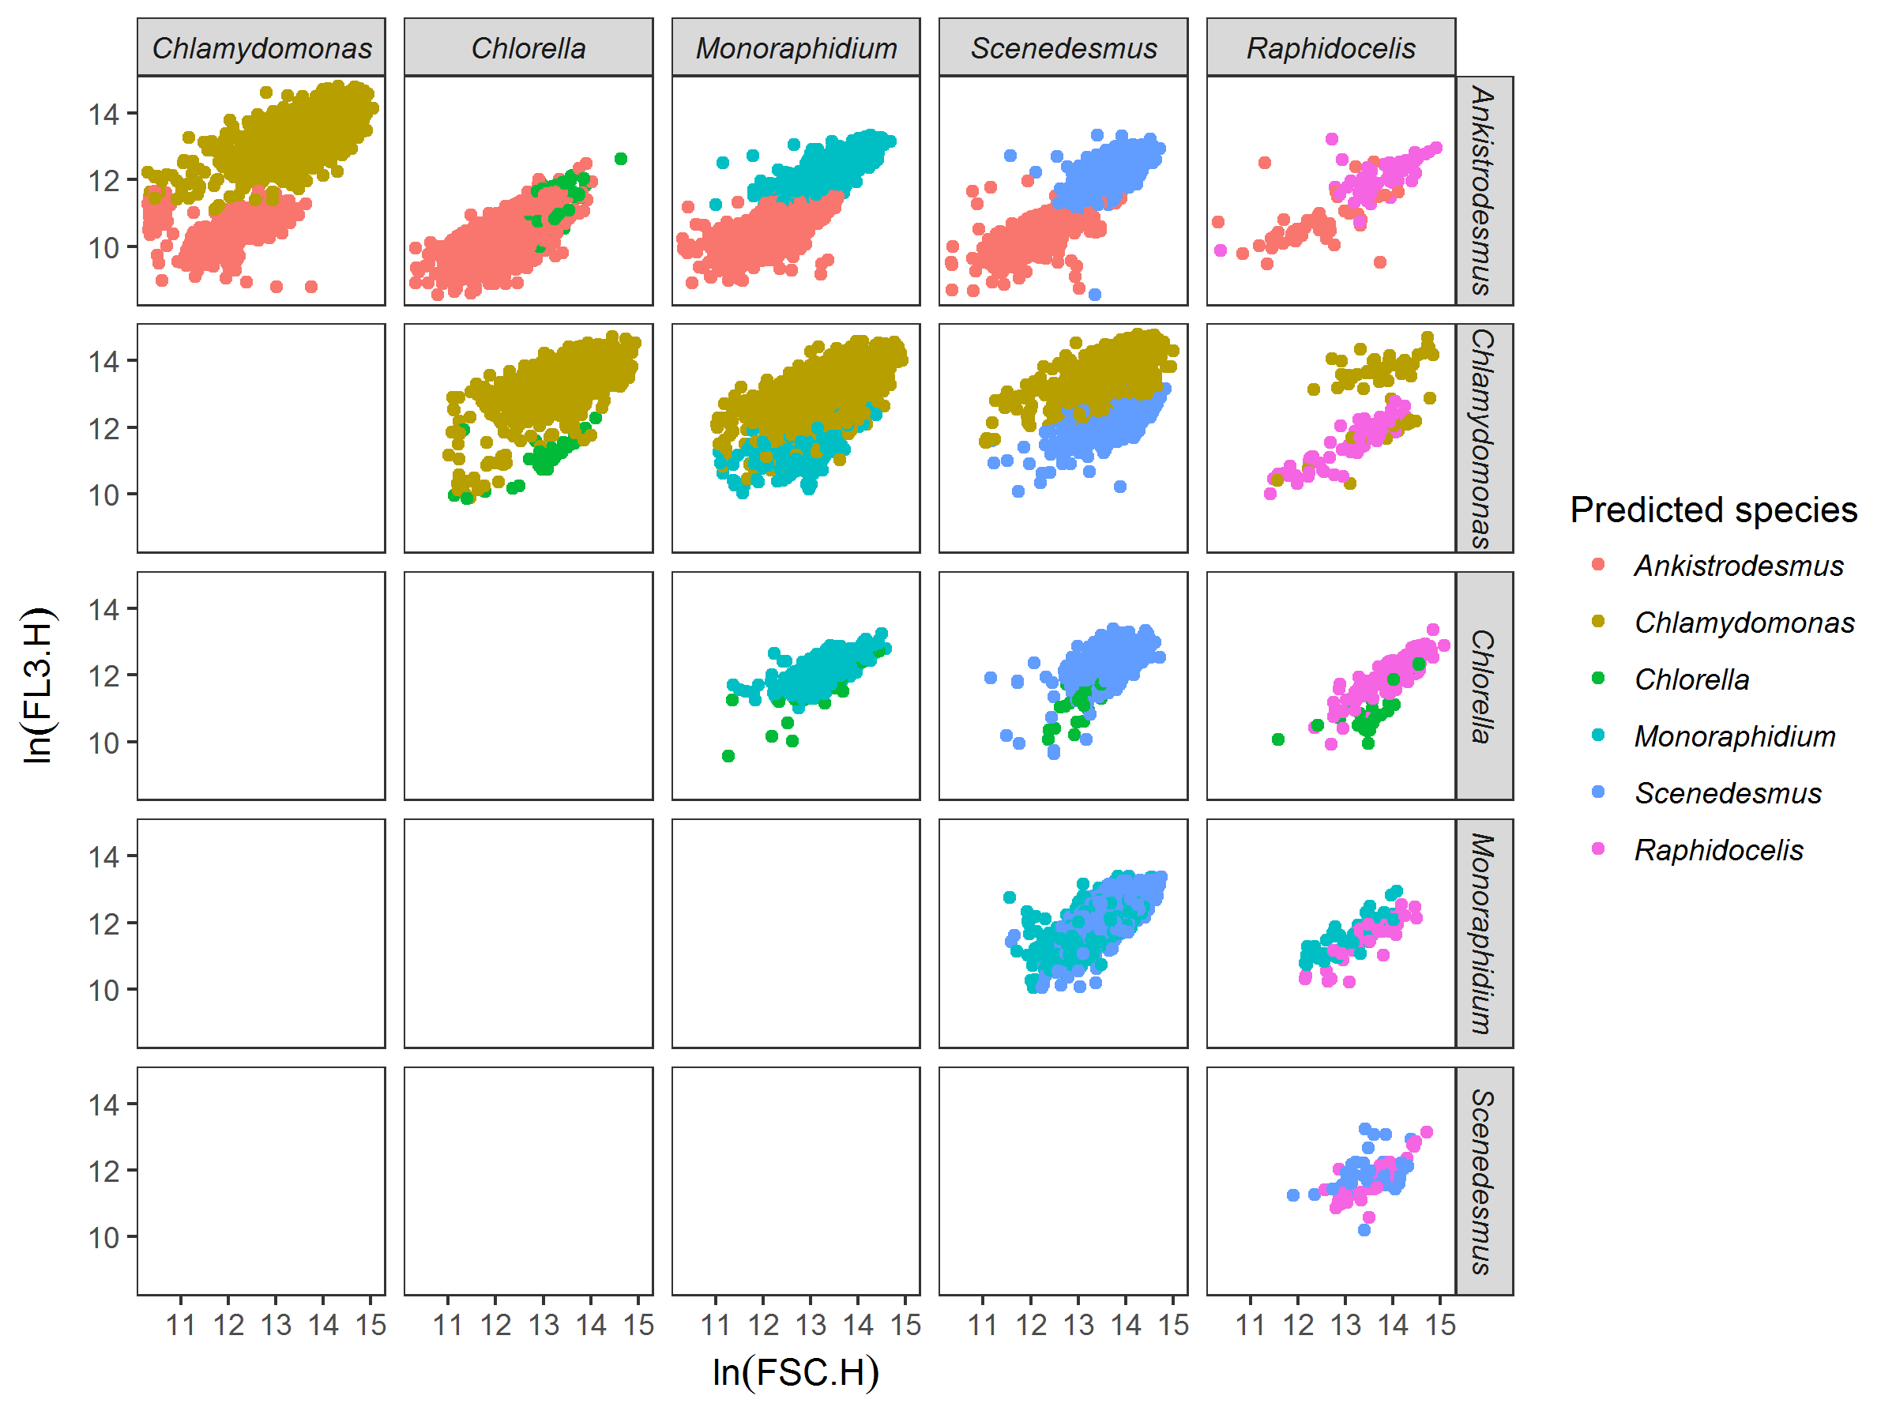

### Figure S3A. Example of discrimination between species among pairs of species. Here for species grown at 15°C in saturating nutrient conditions after 14 days of experiment. Each dot represents a cell, here mapped on FSC.H (size proxy) and FL3.H (chlorophyll a proxy) characteristics from the flow cytometer. Colours represent the species predicted by the discrimination algorithm. The discrimination algorithm is a linear discriminant analysis trained with flow cytometer data (FSC.H, FSC.A, SSC.H, SSC.A, FL1.H, FL1.A, FL2.H, FL2.A, FL3.H, FL3.A, FL4.H, and FL4.A) from the species grown in isolates at the same temperature and nutrient conditions. For example, *Chlamydomonas* has a competitive advantage over *Chlorella* in these nutrient and temperature conditions (more cells from *Chlamydomonas*).

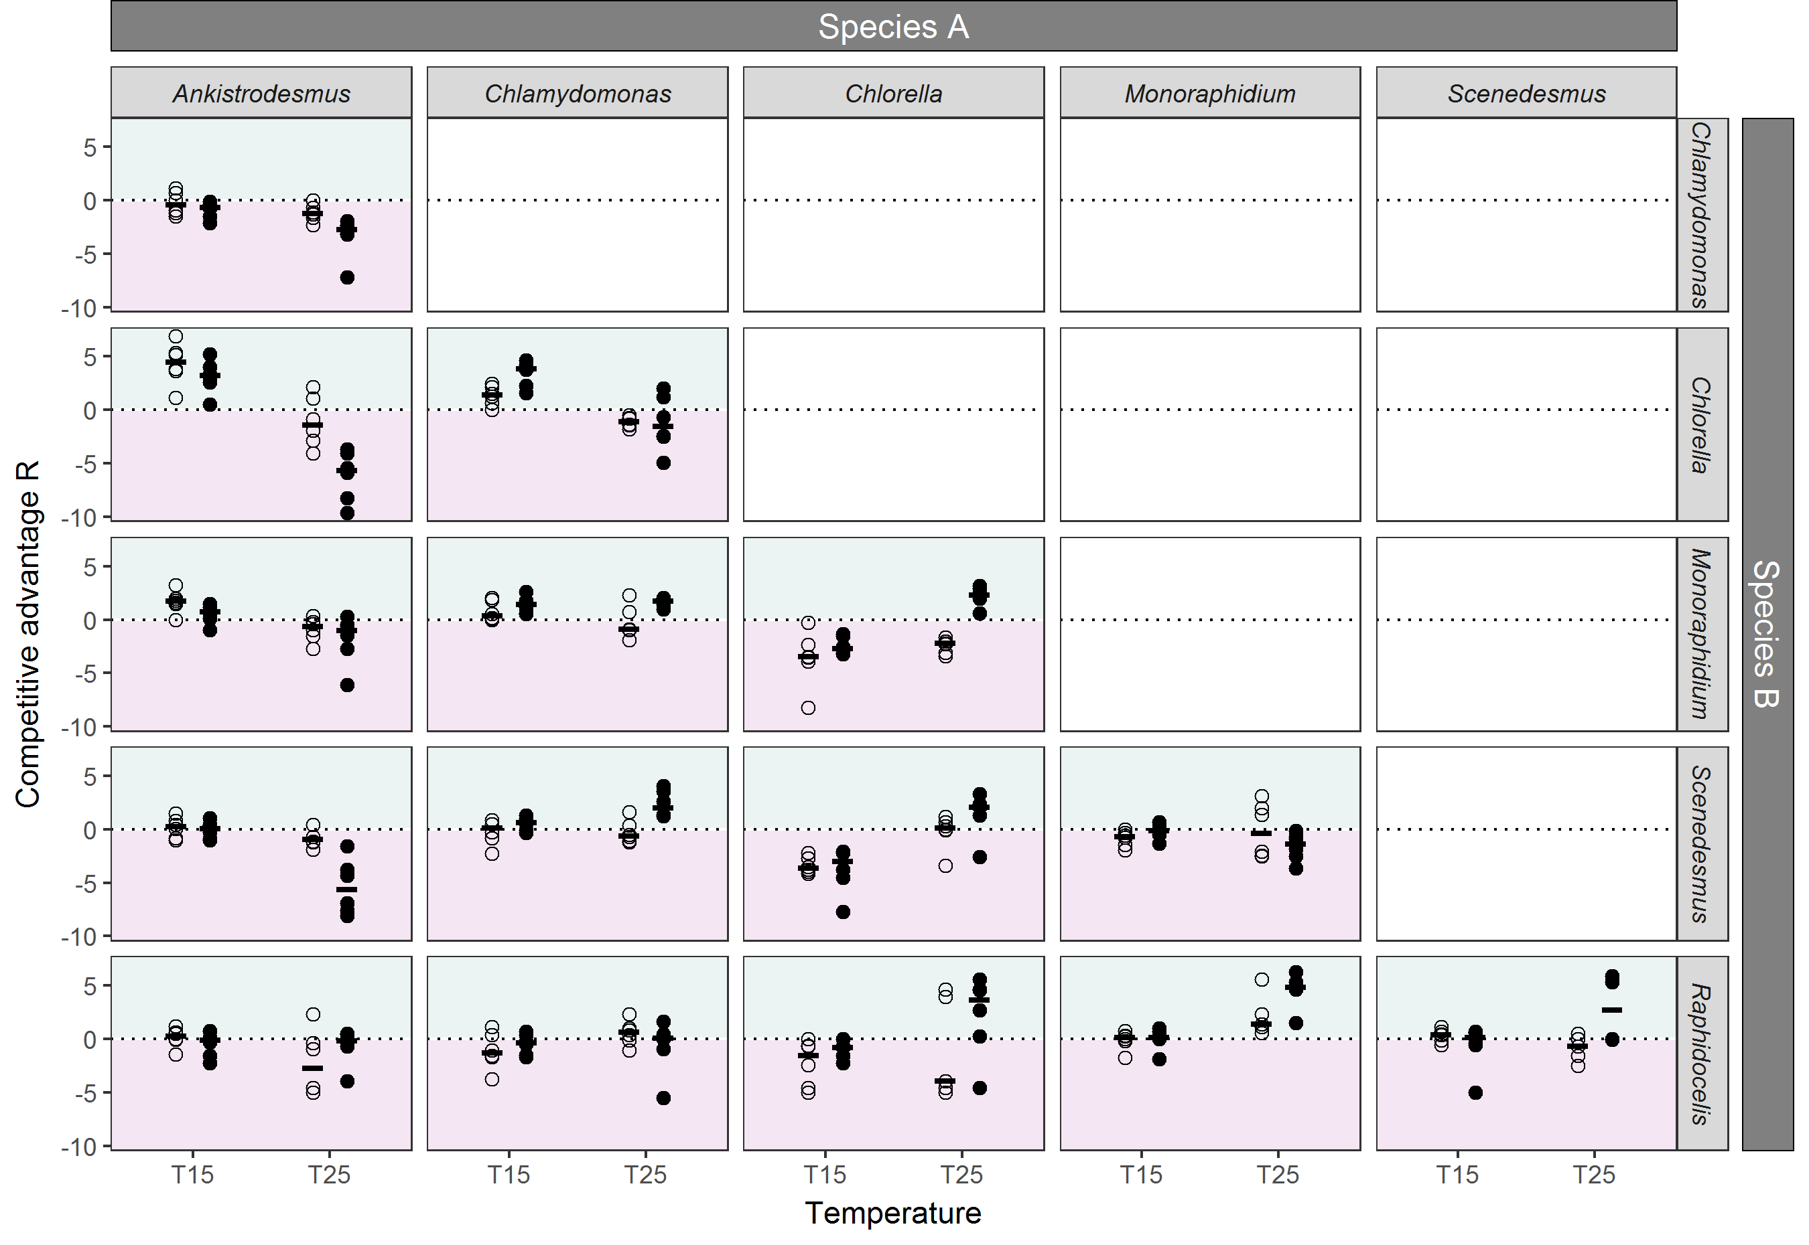

## Figure S3B. Competition outcomes. For each pair of species, the competitive advantage R. Shapes represent the nutrient conditions of the trial, open circles: non-saturated nutrient solution (1 μmol·L-1 of phosphate), closed circles, saturated nutrient solution (30 μmol·L-1 of phosphate). Points represent the values of the 6 replicates per condition, and the black segment represents the median of the 6 replicates. The dotted lines represent the situation where there is no competitive advantage between the species (NA = NB). The area above the line shows an advantage for species A (turquoise colour), while area below the line shows and advantage for species B (pink colour). We can see for instance that for the *Ankistrodesmus-Chlorella* pair of species, *Ankistrodesmus* dominates at low temperatures for all nutrient conditions while *Chlorella* dominates at high temperatures, particularly at high nutrient conditions.

## S4. Temperature dependence of the Monod model parameters

### Table S4A. Metabolic parameters for each alga. Normalization constants ( and resp. for and ) and activation energies ( and resp. for and ) derived from a Boltzmann-Arrhenius model fit on ln scales using nonlinear least squares to the values of and for all replicates, for temperatures between 15 and 25°C, and using a reference temperature °C (estimates ± SE). Note that for some replicates, the Monod model gave *KS* = 0. Because the Boltzmann-Arrhenius model was fit on ln scales and to avoid infinity issues when logging these values, these were set to the minimum quantity of nutrients in the experiment, that is *KS* = 0.001.

|  |  |  |  |  |
| --- | --- | --- | --- | --- |
| **Species** | *KS* | |  | |
|  |  |  |  |  |
| *Ankistrodesmus* | -6.49 ± 0.51 | 3.26 ± 0.59 | -0.39 ± 0.04 | 0.27 ± 0.05 |
| *Chlamydomonas* | -2.47 ± 0.63 | 0.96 ± 0.72 | 0.15 ± 0.07 | 0.16 ± 0.08 |
| *Chlorella* | -2.71 ± 0.19 | 1.49 ± 0.22 | -0.58 ± 0.07 | 0.99 ± 0.08 |
| *Monoraphidium* | -3.44 ± 0.73 | 1.47 ± 0.83 | -0.54 ± 0.09 | 0.59 ± 0.10 |
| *Scenedesmus* | -1.30 ± 0.46 | 0.00 ± 0.52 | 0.22 ± 0.07 | 0.00 ± 0.08 |
| *Raphidocelis* | -1.67 ± 0.46 | 2.91 ± 0.52 | -0.48 ± 0.17 | 0.97 ± 0.20 |

### Table S4B. Results from the GAMs of ln( as a function of temperature, for each species. See Fig. 1 for the representation of the GAMs.

|  |  |  |  |  |
| --- | --- | --- | --- | --- |
| **Species** | **edf** | **F** | **p-value** | **R2** |
| *Ankistrodesmus* | 2 | 8.33 | 0.005** | 0.51 |
| *Chlamydomonas* | 2 | 3.96 | 0.048* | 0.30 |
| *Chlorella* | 2 | 113.6 | >0.001*** | 0.94 |
| *Monoraphidium* | 2 | 70.4 | >0.001*** | 0.91 |
| *Scenedesmus* | 2 | 0.34 | 0.716 | -0.10 |
| *Raphidocelis* | 2 | 10.6 | 0.002** | 0.58 |

### Table S4C. Results from the GAMs of ) as a function of temperature, for each species. See Fig. 1 for the representation of the GAMs.

|  |  |  |  |  |
| --- | --- | --- | --- | --- |
| **Species** | **edf** | **F** | **p-value** | **R2** |
| *Ankistrodesmus* | 2 | 31.6 | >0.001*** | 0.81 |
| *Chlamydomonas* | 2 | 4.39 | 0.037* | 0.33 |
| *Chlorella* | 2 | 27.5 | >0.001*** | 0.79 |
| *Monoraphidium* | 2 | 6.21 | 0.014* | 0.43 |
| *Scenedesmus* | 2 | 1.49 | 0.265 | 0.06 |
| *Raphidocelis* | 2 | 21.6 | 0.001** | 0.75 |

## S5. Significance of competitive advantage predicted by the model.

To quantify the significance of the theory’s ability to predict competitive advantage, we ran the analysis 10,000 times, sampling the values of , , , and independently, with replacement, from the pool of available values. The analysis produced 10,000 sets of predictions, and therefore 10,000 proportions of competitive advantages correctly predicted (e.g., Fig. S5A). The proportion of runs that correctly predicted a greater number of competitive advantages than the real parameter values are then given as the *P* values in Table 1. Therefore, *P*=0.05 means that 500 out of 10,000 random parameter combinations correctly predicted a greater proportion of competitive advantages.

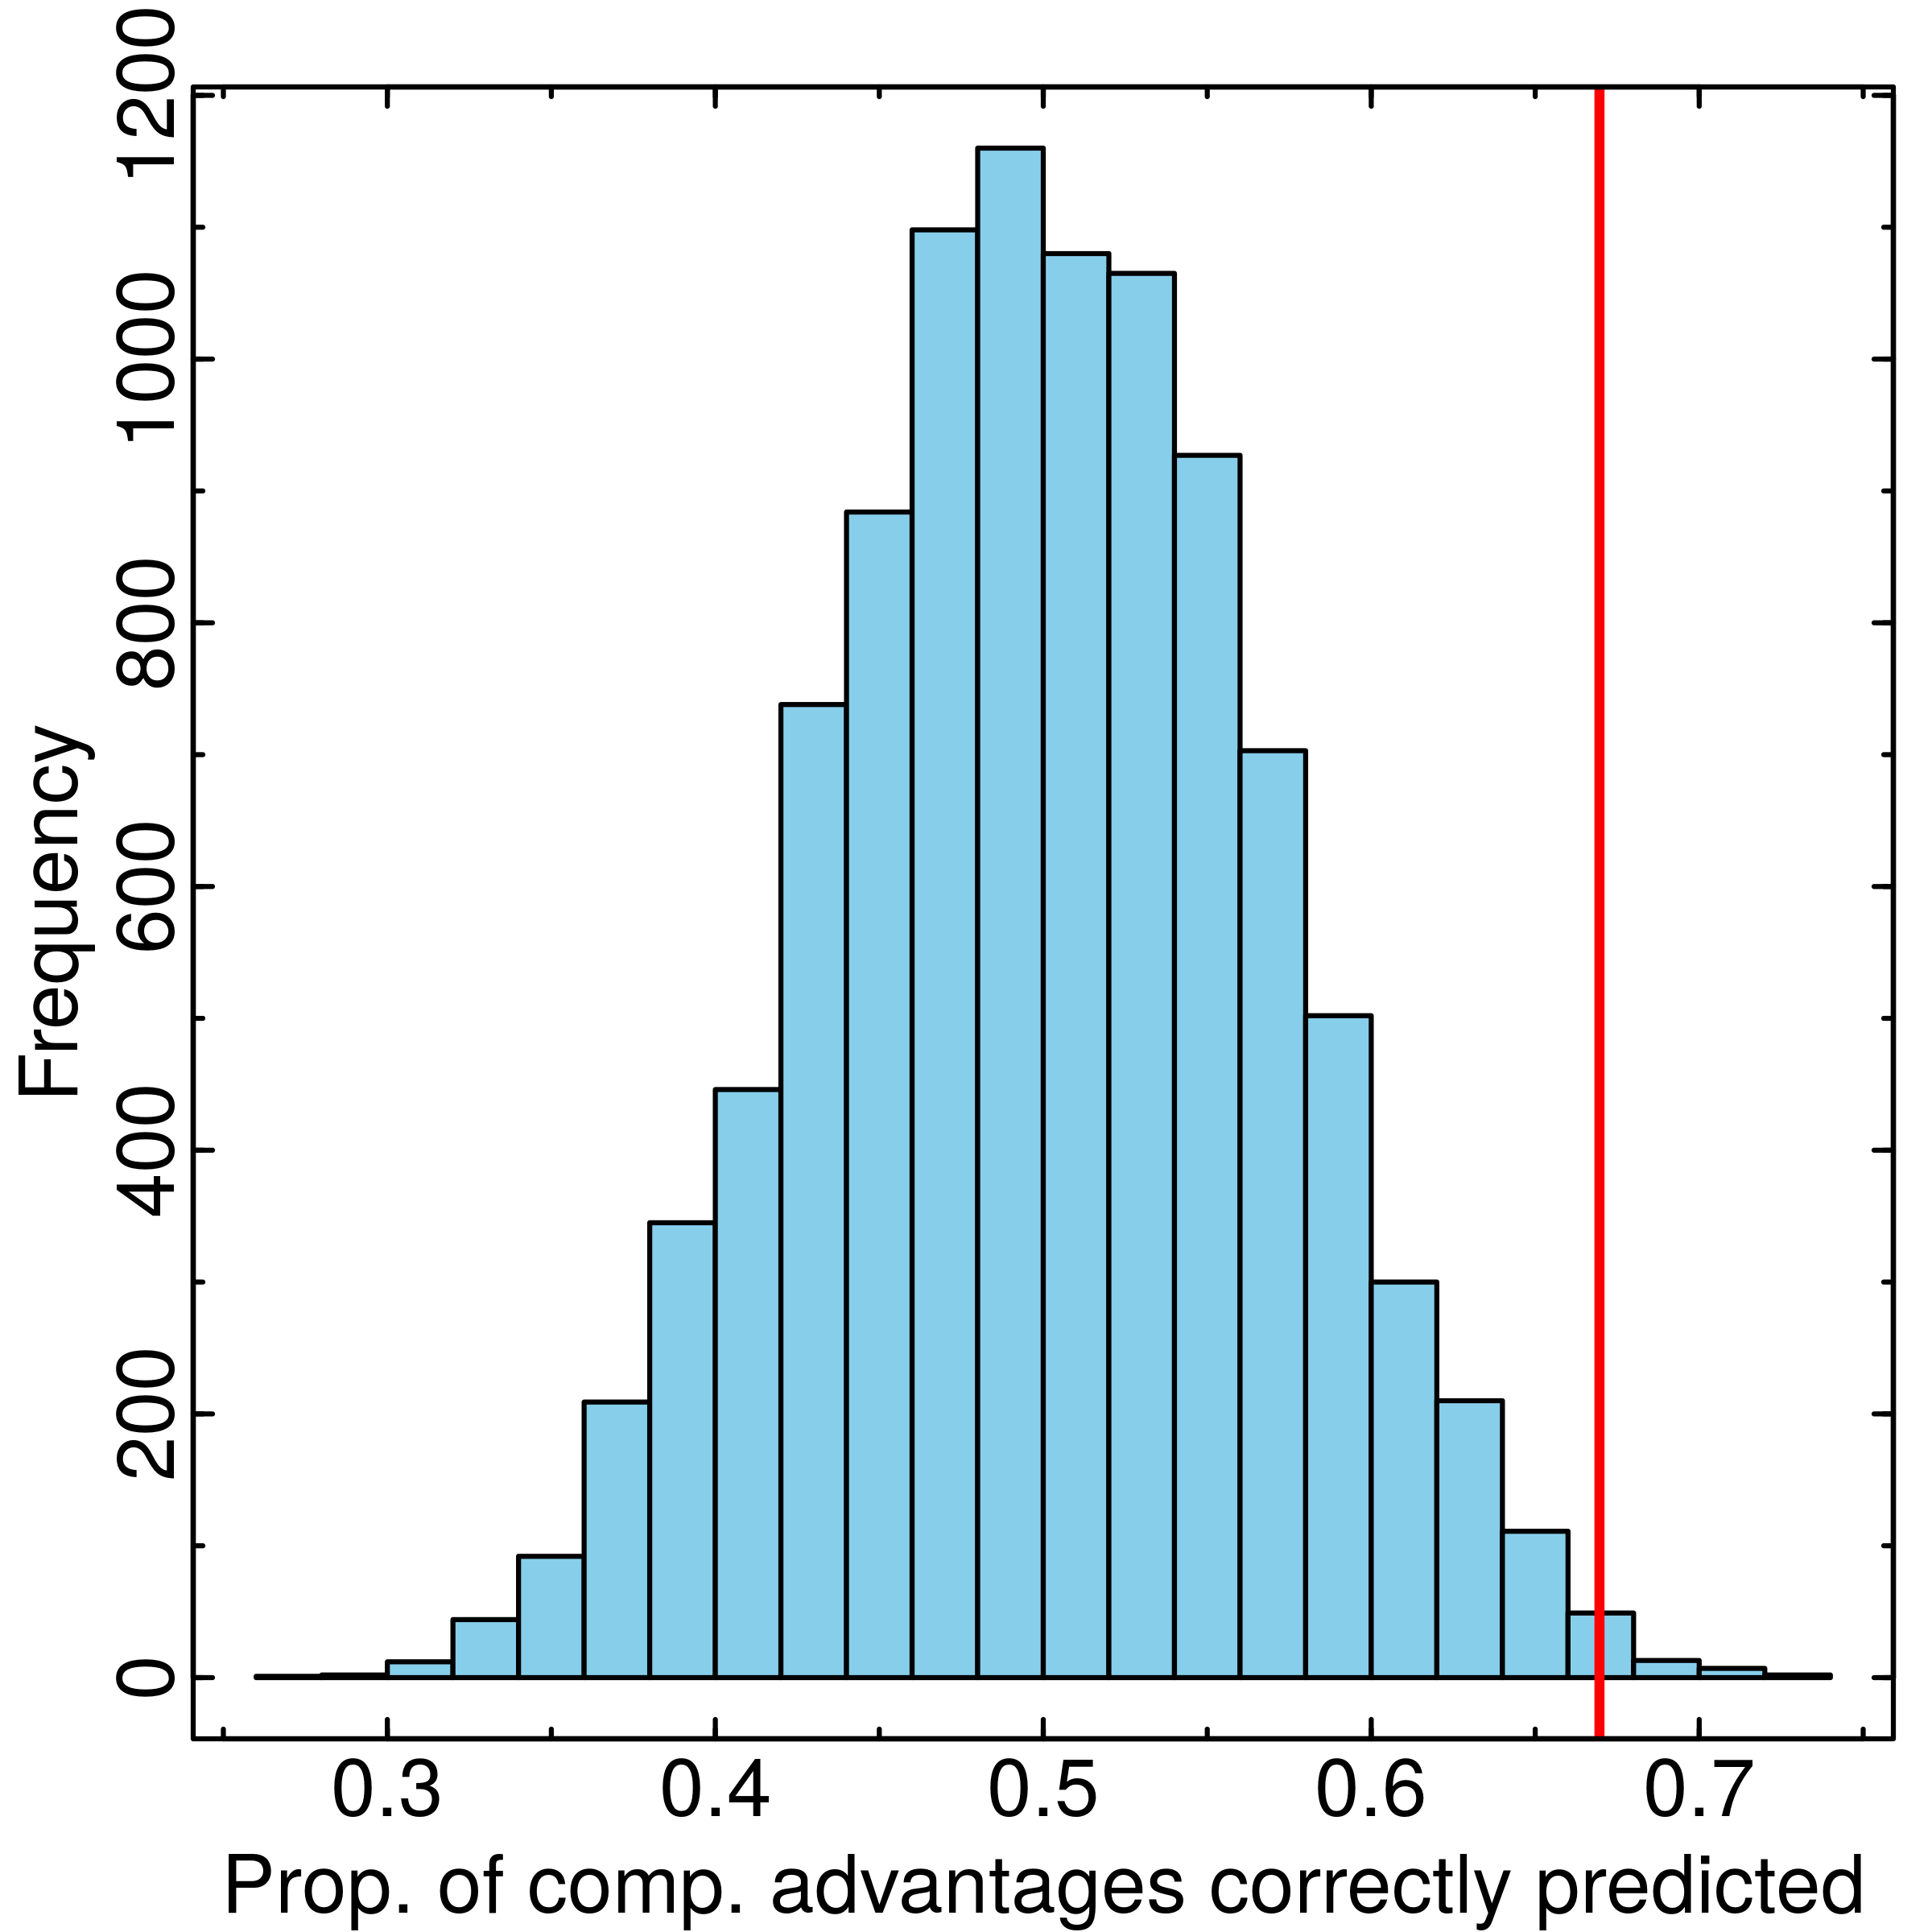

**Figure S5A.** **Histogram of proportions of competitive advantages correctly predicted for 10,000 random parameter combinations.** The real parameters correctly predicted the competitive advantage in 67% of the competitions (red line), and 65 of the 10,000 random parameter combinations produced a greater predictive power (>67% of correct predictions; runs to the right of the red line).

## S6. Robustness of the results to different statistical methods

We used three different methods of discrimination to determine the number of cells from each species, a linear discriminant analysis, a random forest analysis and a recursive partitioning and regression tree (rpart, see Section S3 in SI). Because the linear discriminant analysis was found to have the best predictive power overall (Table S3A), we used this method throughout the manuscript. However, we tested whether our results were robust to the method of species discrimination by comparing results from the competition model to predictions using the random forest analysis and the rpart discrimination method (Table S6A and S6B). The results were similar, with a lower predictive power of each variable and of the model due to the lower discrimination power of the two methods, but no significant discrepancies between species and temperature and nutrient conditions.

### Table S6A. Proportion of competitive advantages correctly predicted by theory using the random forest discrimination method. Same as Table 1 in the main text with a different discrimination method.

|  |  |  | ***R*** |  | ***N*** |
| --- | --- | --- | --- | --- | --- |
| *Full dataset* | | | | | |
|  | 0.63 | (0.025) | 0.66 | (0.006) | 345 |
| *By temperature* | | | | | |
| °C | 0.71 | (0.022) | 0.70 | (0.028) | 175 |
| °C | 0.55 | (0.316) | 0.62 | (0.093) | 170 |
| *By nutrient* | | | | | |
| [P] = 1 µmol·L-1 | 0.57 | (0.178) | 0.60 | (0.097) | 173 |
| [P] = 30 µmol·L-1 | 0.69 | (0.017) | 0.72 | (0.008) | 172 |
| *By species* | | | | | |
| *Ankistrodesmus* | 0.75 | (0.004) | 0.74 | (0.004) | 118 |
| *Chlamydomonas* | 0.66 | (0.010) | 0.67 | (0.015) | 119 |
| *Chlorella* | 0.76 | (0.034) | 0.78 | (0.017) | 116 |
| *Monoraphidium* | 0.59 | (0.120) | 0.63 | (0.053) | 115 |
| *Scenedesmus* | 0.57 | (0.330) | 0.59 | (0.248) | 117 |
| *Raphidocelis* | 0.44 | (0.659) | 0.53 | (0.345) | 105 |

### Table S6B. Proportion of competitive advantages correctly predicted by theory using the rpart discrimination method. Same as Table 1 in the main text with a different discrimination method.

|  |  |  | ***R*** |  | ***N*** |
| --- | --- | --- | --- | --- | --- |
| *Full dataset* | | | | | |
|  | 0.63 | (0.024) | 0.66 | (0.007) | 345 |
| *By temperature* | | | | | |
| °C | 0.70 | (0.029) | 0.70 | (0.023) | 176 |
| °C | 0.55 | (0.314) | 0.61 | (0.120) | 169 |
| *By nutrient* | | | | | |
| [P] = 1 µmol·L-1 | 0.56 | (0.233) | 0.59 | (0.141) | 173 |
| [P] = 30 µmol·L-1 | 0.69 | (0.020) | 0.72 | (0.011) | 172 |
| *By species* | | | | | |
| *Ankistrodesmus* | 0.75 | (0.002) | 0.73 | (0.005) | 116 |
| *Chlamydomonas* | 0.61 | (0.102) | 0.63 | (0.073) | 118 |
| *Chlorella* | 0.77 | (0.020) | 0.78 | (0.018) | 115 |
| *Monoraphidium* | 0.59 | (0.092) | 0.65 | (0.031) | 117 |
| *Scenedesmus* | 0.56 | (0.339) | 0.57 | (0.275) | 117 |
| *Raphidocelis* | 0.47 | (0.589) | 0.56 | (0.243) | 107 |

## S7. Quantitative relationship between theoretical and experimental outcomes

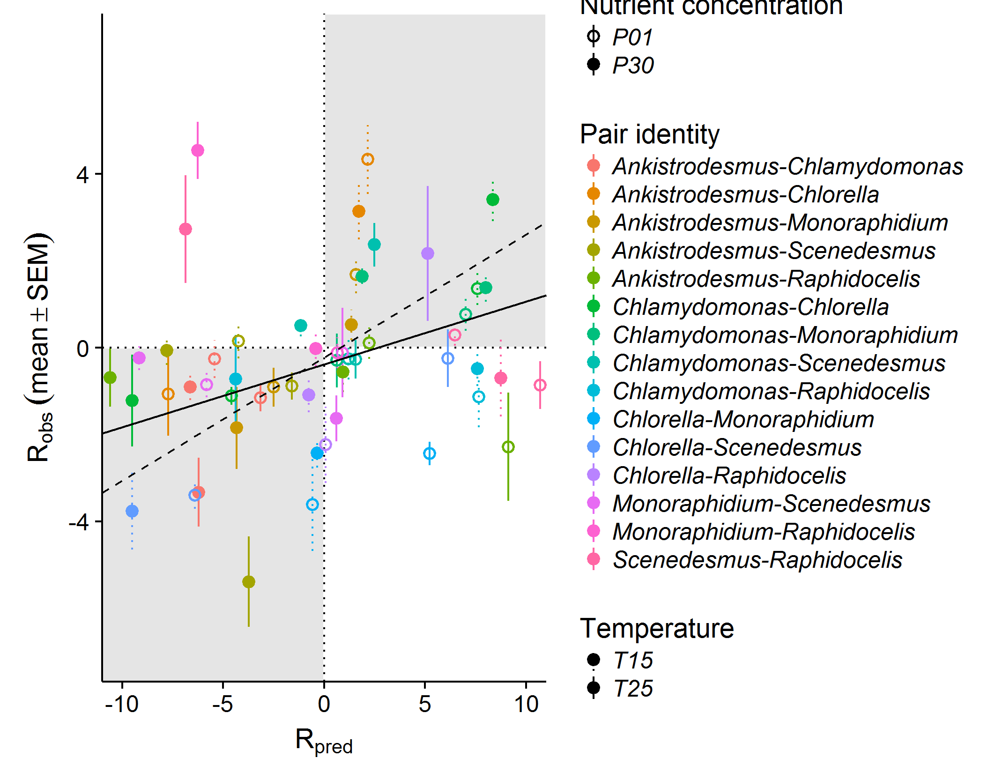

**Figure S7A.** **Correlation between the observed and predicted competitive advantages.** Different species pairs are in different colours, filled circles are for high nutrients while empty circles stand for low nutrients, and the type of the standard error line stands for the temperature (dotted for low temperature, solid for high temperature). Most of the binary experimental outcomes (sign of observed *R*) fall in the same region (grey rectangles) as the binary theoretical outcomes (sign of predicted *R*). The full line represents the results of a linear mixed model of observed *R* as a function of predicted *R* as a fixed effect plus pair ID, temperature and nutrients as random intercepts on the whole dataset, while the dashed line represents the results from the same model but excluding pairs involving *Raphidocelis* (see Table S7A and Table S7B for details about the model).

**Table S7A. Results from the linear mixed model investigating observed *R* as a function of predicted *R****.* Model includes predicted *R* as a fixed effect plus plus pair ID, temperature and nutrients as random intercepts with lmer function from lme4 package (Robs ~ Rpred + (1|temperature) + (1|nutrient) + (1|species pair)).

|  |  |  |  |  |  |
| --- | --- | --- | --- | --- | --- |
| **Factor** | **Estimate** | **SE** | **t-value** | **χ2 statistics** | **R2** |
| *Fixed effect* |  |  |  |  | ***marginal R2*** |
| Rpred | 0.14 | 0.02 | 6.72 | χ2 = 45, p > 0.001 | 0.13 |
| *Random effect* | **Variance** |  |  |  | ***conditional R2*** |
| Temperature | 0.02 |  |  |  | 0.27 |
| Nutrient | 0.25 |  |  |  |  |
| Pair identity | 0.75 |  |  |  |  |
| Residual | 5.36 |  |  |  |  |

**Table S7B.** **Results from the linear mixed model investigating observed *R* as a function of predicted *R* excluding pairs involving *Raphidocelis.*** Model includes predicted R *.* on the competition dataset excluding pairs involving *Raphidoceli*Model includes predicted *R* as a fixed effect plus plus pair ID, temperature and nutrients as random intercepts with lmer function from lme4 package (Robs ~ Rpred + (1|temperature) + (1|nutrient) + (1|species pair))*s*.

|  |  |  |  |  |  |
| --- | --- | --- | --- | --- | --- |
| **Factor** | **Estimate** | **SE** | **t-value** | **χ2 statistics** | **R2** |
| *Fixed effect* |  |  |  |  | ***marginal R2*** |
| Rpred | 0.28 | 0.02 | 12,18 | χ2 = 148.5, p > 0.001 | 0.36 |
| *Random effect* | **Variance** |  |  |  | ***conditional R2*** |
| Temperature | 0.60 |  |  |  | 0.57 |
| Nutrient | 0.00 |  |  |  |  |
| Pair identity | 1.21 |  |  |  |  |
| Residual | 3.54 |  |  |  |  |

**Table S7C.** **Link between observed and predicted *R* by species**. Results from a mixed effect model of Robs ~ Rpred + (1|temperature)+(1|nutrient)+(1|species pair) for each subset of competitions.

|  |  |  |  |  |  |
| --- | --- | --- | --- | --- | --- |
| **Species** | **Fixed Rpred effect** | | **t-value** | **Marginal R2** | **Conditional R2** |
|  | **estimate** | **SD** |  |  |  |
| *Ankistrodesmus* | 0.11 | 0.04 | 2.54 | 0.04 | 0.53 |
| *Chlamydomonas* | 0.17 | 0.03 | 6.04 | 0.26 | 0.47 |
| *Chlorella* | 0.29 | 0.03 | 9.43 | 0.37 | 0.61 |
| *Monoraphidium* | 0.11 | 0.04 | 2.88 | 0.06 | 0.39 |
| *Scenedesmus* | 0.06 | 0.04 | 1.81 | 0.03 | 0.13 |
| *Raphidocelis* | -0.04 | 0.04 | -1.12 | 0.01 | 0.24 |

## S8. Impact of competitive interactions on polyculture yield.

We computed the total cell density of the two species grown in competition and the total cell density of each species grown isolation. We calculated a deviation from expected yield according to Loreau & Hector 2001, as

where is the observed yield of the two-species mixture (in cells·mL-1), is the expected yield of the two-species mixture, and and are the observed and expected relative yields of species *i* in the mixture. The expected relative yield of species *i* in the mixture are equal to half of the yield observed in monoculture (as they have theoretically access to half of the nutrients in a two-species mixture). We studied whether the deviation from expected yield varied with species identity (Table S8A). Positive deviations indicate complementarity effects (e.g. niche partitioning or facilitation) while negative deviations indicate competitive interactions diminishing total biomass. Although all interactions were generally negative, interactions involving *Raphidocelis* were strongly negative, while interactions involving *Scenedesmus* were less negative (Table S8A).

***References***

Loreau, M. & Hector, A. (2001). Partitioning selection and complementarity in biodiversity experiments. *Nature*, 412, 72–76

**Table S8A**. **Deviation from the expected yield per species**. Values from two tailed t test of

|  |  |  |  |  |  |
| --- | --- | --- | --- | --- | --- |
| **Species** | **mean** | **Confidence interval** | **t-value** | **df** | **pvalue** |
| *Ankistrodesmus* | -0.36 | [-0.48,-0.25] | -6.30 | 119 | >0.001*** |
| *Chlamydomonas* | -0.16 | [-0.25,-0.06] | -3.31 | 119 | 0.001** |
| *Chlorella* | -0.15 | [-0.27,-0.04] | -2.63 | 119 | 0.009** |
| *Monoraphidium* | -0.14 | [-0.22,-0.06] | -3.43 | 118 | >0.001*** |
| *Scenedesmus* | -0.12 | [-0.23,-0.01] | -2.22 | 119 | 0.028* |
| *Raphidocelis* | -0.74 | [-0.85,-0.63] | -13.40 | 119 | >0.001*** |